VOLUNTEERISM & TEAMWORK
SAHRMA is an organization made up of an all-volunteer board, committees, members, and one Chapter Management Professional who, among many other things, is our SAHRMA Google. Year after year, since 1959, SAHRMA has carried on the mission of elevating San Antonio’s HR community by promoting professional development and personal growth through education, networking and volunteerism.
SAHRMA strives to offer a variety of opportunities for all members to get involved. We all have our “day jobs” and then we get to pick which areas of community service we want to dedicate our time and talent to. Each year, the individuals that make up the SAHRMA Board and committees have a potluck of skills, education and HR experience. Each individual gets involved to the extent that they can commit to and somehow it all comes together nicely.
SAHRMA is always looking for new volunteers, bringing what they will to the table and new ideas. Some traditions last throughout the years and then some new ways to CONNECT, SERVE, and LEARN get adopted. The pandemic has taught us how to pivot and adapt to new ways of delivering content and keeping in touch. It has also made us realize what works best for our organization. Figuring this out as we go along is a challenge, but we have done so as a team.
As the 2021 President, I believe that 17 heads are better than one, so I rely heavily on the board for their input and ideas. Regaining, increasing and retaining membership is one of my priorities. Developing the next slate of board members is another. As we increase our in-person events, I am getting to know some of the new SAHRMA “regulars”. Staying an active member of SAHRMA is how you will become familiar with the organization, meet new contacts, establish resources, and make new friends. When you are a SAHRMA volunteer, you are making a difference for SAHRMA members, students and at-large SHRM members.
We recently held our first statewide SHRM Chapter Top Golf Tournament on June 10th. SAHRMA competed with the SHRM Chapters of Dallas, El Paso, Austin and Mid-Cities. Our goal was to raise $500 for the SHRM Foundation. We raised a total of $1,306! We couldn’t have done it without the teamwork of the SAHRMA BOD, volunteers, generous sponsors and of course those competitive corporate teams!
Our donations to the SHRM Foundation contribute to awarding scholarships and professional development grants to educate and develop students and HR professionals. SAHRMA recently saw this come full circle with two of our TAMUSA students Leila Muzquiz and Rose Hernandez being selected to receive 2021 Academic Scholarships from the SHRM Foundation. To have two students in the same semester from the same SHRM chapter receive these scholarships is unprecedented! So, if you ever had any doubt if your volunteerism, sponsorship, or participation in a fundraiser makes a difference, it absolutely does!
Have you ever seen on Facebook those memes that say, “I don’t know who needs to hear this but…”? Well, I don’t know who needs a sign to go ahead and get more involved with SAHRMA, but emailing this form SAHRMA-Volunteer Form.pdf to volunteer@SAHRMA.org is a start.

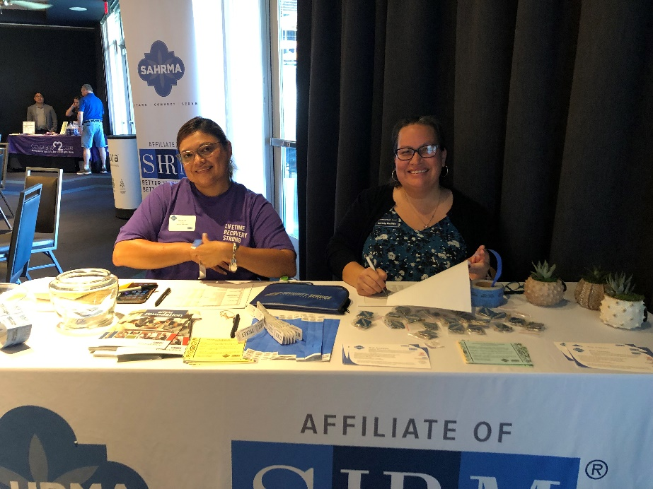

SAHRMA Volunteers Rebecca Tepe and Christy Ratliffe at Top Golf Event on June 10, 2021

