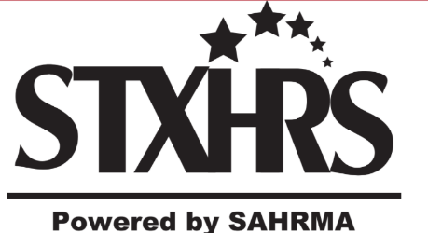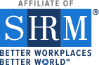

San Antonio Human Resource Management Association’s South Texas HR Symposium 2023

In-Person at the Norris Conference Center
San Antonio, Texas – Thursday, March 2, 2023

SPONSORSHIP OPPORTUNITIES
SAHRMA’s STXHRS 2023 Symposium is dedicated to providing a quality and affordable certified program for attendees to help today’s HR professionals stay on top of business trends and employment best practices that are critical to their companies’ successes. We expect over 150 HR professionals who devote their time, effort, and energy to the future and direction of Human Resources for the local, regional, and national companies for which they work.

In 2023 our program will look very different, including limited premium sponsorships available. Becoming a sponsor provides your organization with high visibility to a large number of highly influential leaders, while assisting the non-profit SAHRMA organization in funding this valuable event for professional members and guests. We know that budgets are limited as many companies emerge from the financial impact of COVID-19. We have worked to identify these exclusive sponsorship opportunities in hopes of defraying even just part of SAHRMA’s expenses, and in return, bring value to our sponsors.

Platinum Sponsor - $3,500
The Platinum Sponsor will receive the following benefits:
- Recognition during the “Welcome and Introduction” by the STXHRS2023 Chair and a representative will be allowed a 3-minute presentation to attendees.
- Four (4) entrance tickets to the event.
- Six-foot display table with exclusive location within the entrance of Event Ballroom.
- Presence of corporate logo on all marketing materials for STXHRS2023 from the date the sponsorship application is processed through the event. This includes on the SAHRMA website and in SAHRMA e-mail blasts.
- Recognition on each STXHRS promotion on social media platforms.
- Corporate logo on display board at entrance of the event.
- Attendee listing
- Branded Premium Swag item (determined by options available for this level)

Gold Sponsor - $2,500
The Gold Sponsor will receive the following benefits:
- Will be allowed a 3-minute presentation to attendees in a Breakout Session.
- Three (3) entrance tickets to the event.
- Six-foot display table within the Event Ballroom.
- Presence of corporate logo on limited marketing materials for STXHRS2023 from the date the sponsorship application is processed through the event. This includes on the SAHRMA website and in SAHRMA e-mail blasts.
- Monthly recognition on social media platforms.
- Corporate logo on display board at entrance of the event.
- Attendee Listing
- Branded Swag Item or Recognition of sponsoring Event Mixer (determined by options available for this level)

Silver Sponsor - $1,500
The Silver Sponsor will receive the following benefits:
- Two (2) entrance tickets to the event.
- Six-foot display table within the Event Ballroom.
- Recognition on SAHRMA website
- One (1) recognition on social media platforms
- Corporate logo on display board at entrance of the event.
- Attendee Listing
- Recognition for sponsoring Breakfast, Lunch, Snack, or Vol. Appreciation dinner.

Door Prize Sponsors – varying values
Door prize sponsors will receive the following benefits:
- Will be recognized during the door prize give-a-ways by the STXHRS2023 Chair and on website

